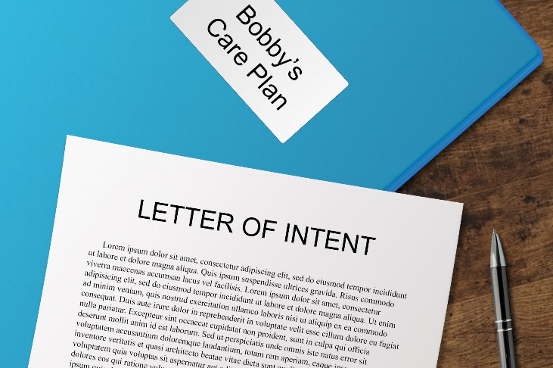
For Parents of Students with Special Needs:

Transition
Workshop

Come work with the PISD Transition Team to:
- Create a care binder to keep all of your special needs child’s important information organized

- Begin writing a letter of intent to document important information about your child’s needs, preferences, routines, and your desires for his or her future

- Consult with PISD staff about transition topics, community resources, and other transition-related matters
Thursday, February 7, 2019
6:30 – 8:00 PM
Prosper ISD Administration Building Board Room
605 East Seventh Street
Please RSVP by February 1st through the link below or by emailing Julia Chalker at jtchalker@prosper-isd.net.
https://goo.gl/forms/XThPCOv7FurhtUXR2
***Childcare is also available by reservation through the same link.***
For more information, please contact Julia Chalker, Prosper ISD Transition Specialist, at jtchalker@prosper-isd.net or 469-219-2000, ext. 13224.
Prosper ISD Special Needs Resources – be sure to LIKE our page!

