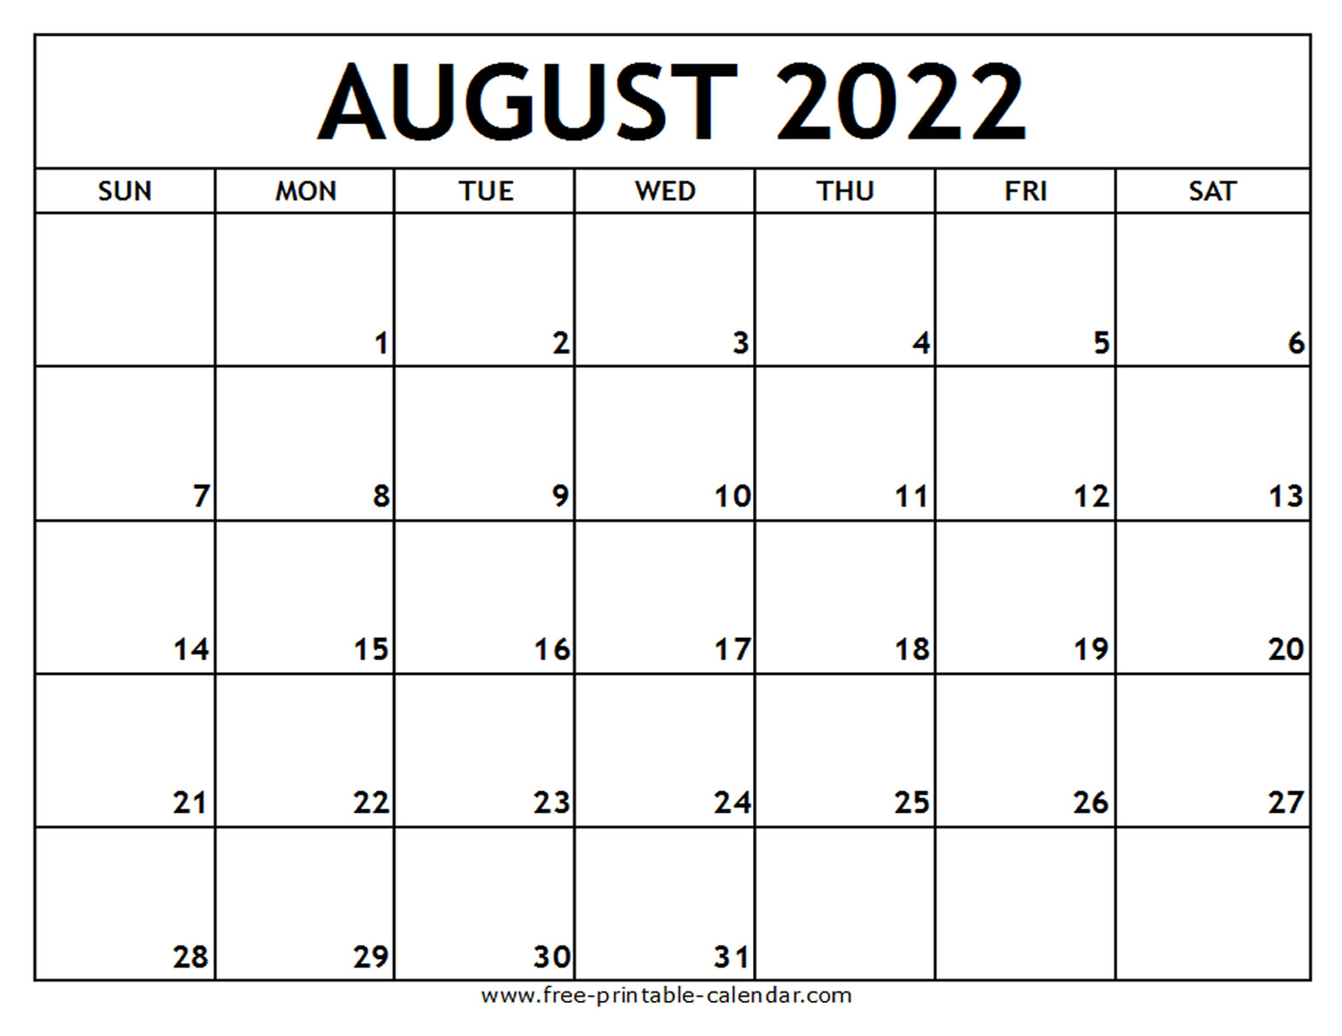

**FIRST DAY OF SCHOOL**

**JV Practice**

8:30am at the tennis courts (DO NOT DRESS OUT!)

**Varsity vs Coppell Mound HS**

**@ CHS at 4:00pm**

**JV Practice**

7:30am

**Varsity Practice**

Until 4:45pm

**Player-Parent**

**Meeting 6:00pm**

**JV Practice**

7:30am

**Varsity vs Rock Hill @**

**PHS 4:00pm**

**JV Practice**

7:30am

**JV vs Denton Guyer @ Guyer 4:30pm**

**JV Practice**

7:30am

**Varsity Practice**

Until 4:45pm

**JV Practice**

7:30am

**Varsity Practice**

Until 4:45pm

**JV Practice**

7:30am

**Varsity Practice**

Until 4:45pm

**JV Practice**

7:30am

**Varsity vs Flower Mound HS @ FMHS @ 4:30pm**

**JV Practice**

7:30am

**Varsity Practice**

Until 4:00pm

**JV vs McKinney HS**

**4:30pm @ MHS**

**Varsity Practice**

4:00-6:00pm

**Varsity vs**

**San Angelo Central HS @ PHS at 2:00pm**

**JV Practice**

7:30am

**Varsity Practice**

Until 4:45pm

**JV Practice**

7:30am

**Varsity vs Denton Guyer @ Guyer 4:30pm**

**JV Practice**

7:30am

**Varsity Practice**

Until 4:45pm

**JV Practice**

7:30am

**Varsity Practice**

Until 4:45pm

**JV Practice**

7:30am

**Varsity Practice**

Until 4:45pm

**JV Practice**

7:30am

**Varsity Practice**

Until 4:00pm

**Meet the Eagles 7:00pm**

**JV Practice**

7:30am

**Varsity Practice**

Until 4:45pm

**Team Pictures**

11:00am in the PHS Arena

**Varsity vs Wakeland HS @ PHS at 3:00pm**

**Varsity vs Independence HS @ IHS at 4:00pm**

**Teachers Back to School**

**Varsity Practice**

4:00-6:00pm

**Varsity Practice**

8:00-10:00am

**Open Court**

10:00am-12:00pm