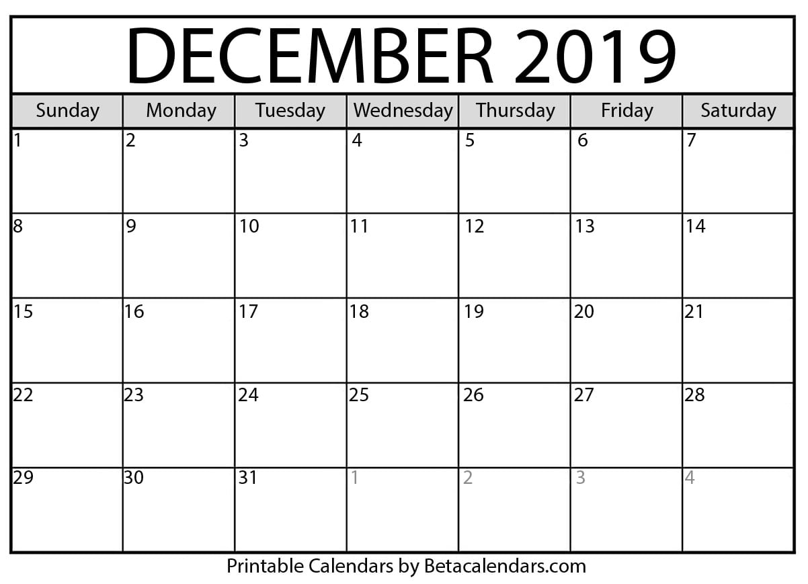

ENJOY YOUR HOLIDAY BREAK!!!

Kid’s come back to school on January 7th.

**Last Day of the Semester!**

JV meets at 8:30am. We will not see Varsity.

School’s out at 12:50

JV 8:30am

Varsity: 4:00pm

JV 8:30am

Varsity: 4:00pm

JV 8:30am

Varsity: 4:00pm

JV 8:30am

Varsity: 4:00pm

JV 8:30am

Varsity: 4:00pm

**TEAM HOLIDAY PARTY @ THE DENTONS**

JV 8:30am

Varsity: 4:00pm

JV 8:30am

Varsity: 4:00pm

JV 8:30am

Varsity: 4:00pm

JV 8:30am

Varsity: 4:00pm

JV 8:30am

Varsity: 4:00pm

JV 8:30am

Varsity: 4:00pm

JV 8:30am

Varsity: 4:00pm

JV 8:30am

Varsity: 4:00pm

JV 8:30am

Varsity: 4:00pm

ETF Meeting 6:00pm