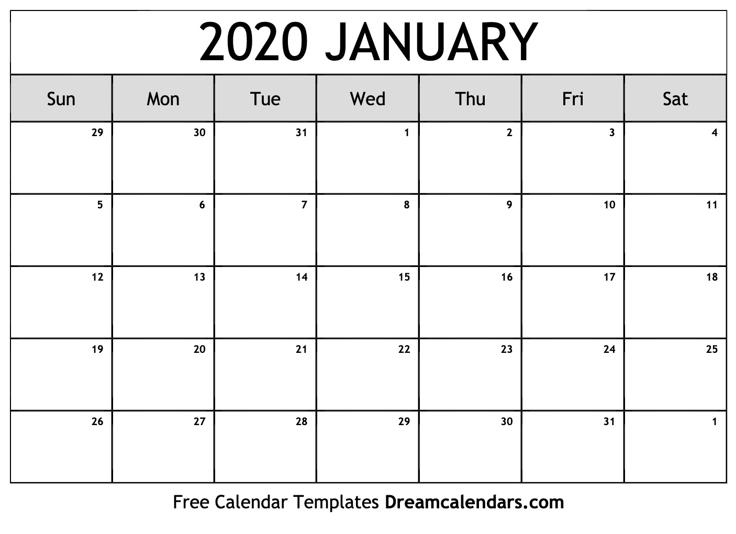

**Varsity Matches: January 21st & January 28th**

**Eagle Tennis Foundation Meeting, January 27th at 6:00pm in the Small MPF Classroom**

JV 7:50am

**Varsity vs McKinney HS at PHS @4:00pm**

JV 7:50am

**Varsity vs Liberty HS at LHS 4:00pm**

JV 7:50am

Varsity

Until 4:30pm

**ETF MEETING 6:00PM**

JV 7:50am

Varsity

Until 4:30pm

JV 7:50am

Varsity

Until 4:30pm

JV 7:50am

Varsity

Until 4:30pm

No School

JV 7:50am

Varsity

Until 4:30pm

JV 7:50am

Varsity

Until 4:30pm

JV 7:50am

Varsity

Until 4:30pm

JV 7:50am

Varsity

Until 4:30pm

JV 7:50am

Varsity

Until 4:30pm

JV 7:50am

Varsity

Until 4:30pm

JV 7:50am

Varsity

Until 4:30pm

JV 7:50am

Varsity

Until 4:30pm

JV 7:50am

Varsity

Until 4:30pm

JV 7:50am

Varsity

Until 4:30pm

JV 7:50am

Varsity

Until 4:30pm

JV 7:50am

Varsity

Until 4:30pm