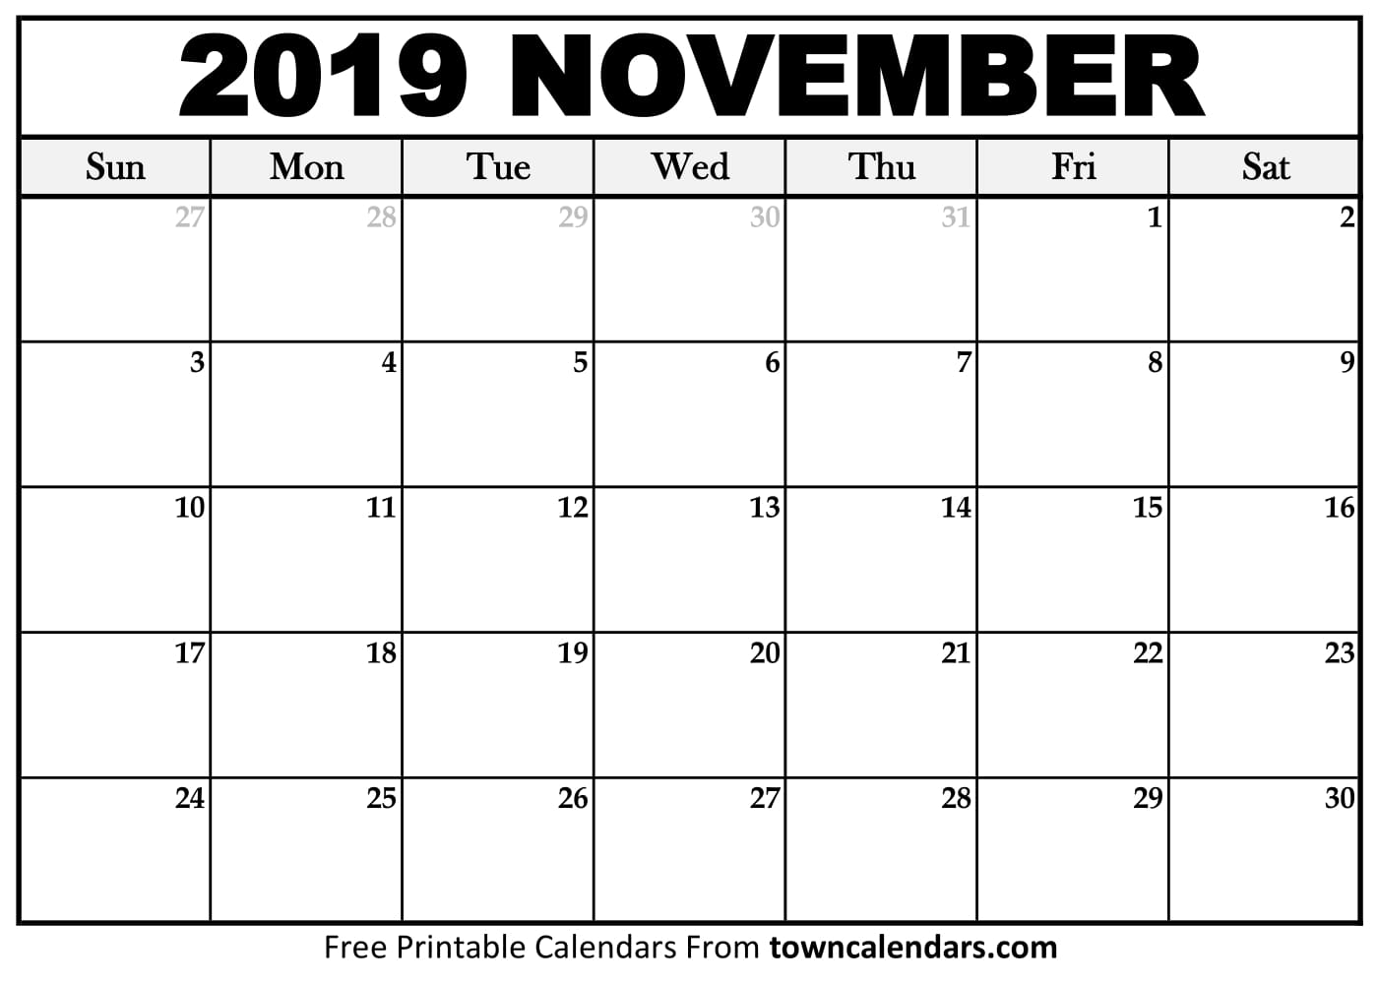

**JV Practice**

8:30 am

**Varsity Practice**

Until 4:00 pm

**Coach Cunningham BDAY! ☺**

* November 14h: JV/VARSITY DUAL 5-7:30 PM
* November 16th: Coach Cunningham Baby Shower 11-1:00 PM at Henry Tolbert’s House
* November 18th: ETF Meeting 6:00 PM in the MPF Classroom

**JV Practice**

8:30 am

**Varsity Practice** until 4:00 pm

**ETF Meeting 6 PM**

**Coach Cunningham Baby Shower**

**11-1:00 AM**

**JV Practice**

8:30 am

**Varsity Practice** until 4:00 pm

**JV/Varsity DUAL**

**5-7:30 PM**

**OPEN COURT**

**9:30-11:00 AM**

**OPEN COURT**

**9:30-11:00 AM**

**JV Practice**

8:30 am

**Varsity Practice** until 4:00 pm

**JV Practice**

8:30 am

**Varsity Practice** until 4:00 pm

**JV Practice**

8:30 am

**Varsity Practice** until 4:00 pm

**THANKSGIVING BREAK!!!!!!!**

**JV Practice**

8:30 am

**Varsity Practice** until 4:00 pm

**JV Practice**

8:30 am

**Varsity Practice** until 4:00 pm

**JV Practice**

8:30 am

**Varsity Practice** until 4:00 pm

**JV Practice**

8:30 am

**Varsity Practice** until 4:00 pm

**JV Practice**

8:30 am

**Varsity Practice** until 4:00 pm

**JV Practice**

8:30 am

**Varsity Practice** until 4:00 pm

**JV Practice**

8:30 am

**Varsity Practice** until 4:00 pm

**JV Practice**

8:30 am

**Varsity Practice** until 4:00 pm

**JV Practice**

8:30 am

**Varsity Practice** until 4:00 pm

**JV Practice**

8:30 am

**Varsity Practice** until 4:00 pm