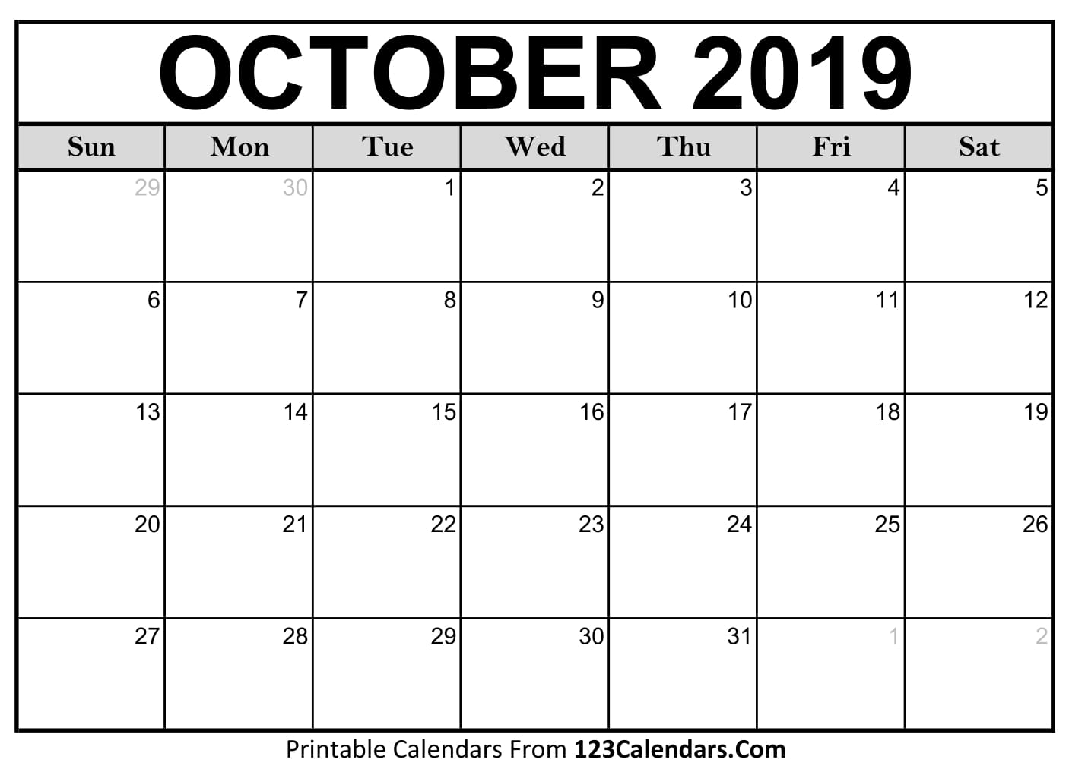
- October 28th ETF Meeting 6:00pm in the MPF Classroom
NO SCHOOL! Teacher Work Day!
Open Court 8:30-3:30 pm

NO SCHOOL!

Varsity Practice
3-5pm

JV Practice
8:30 am
Varsity vs Plano East @ 5:15PM @ PHS
JV Practice
8:30 am
Varsity Practice until 4:30 pm

JV Practice
8:30 am
Varsity Practice until 4:30 pm

JV Practice
8:30 am
Varsity District vs Plano West 4:15pm

JV Practice
8:30 am
Varsity
Bi-District Match Location TBD

JV Practice
8:30 am
Varsity Practice until 4:00 pm
**Homecoming game!**

JV Practice
8:30 am
Varsity Practice **tentative
Area Match Location TBD

JV Practice
8:30 am
Varsity Practice until 4:30 pm
ETF Meeting 6 pm

JV District Tournament 11:30 @ Collin College
Varsity Practice until 4:00 pm

JV Practice
8:30 am
Varsity Practice until 4:30 pm

JV Practice
8:30 am
Varsity Practice until 4:30 pm

JV Practice
8:30 am
Varsity Practice until 4:30 pm

JV Practice
7:50 am
Varsity PLAYOFFS @ PHS 4:45pmvs. Plano Senior

JV Practice
7:50 am
Varsity Practice until 4:30 pm

JV Practice
7:50 am
Varsity Practice
4:30pm
JV Practice
8:30 am
Varsity Practice until 4:00 pm

JV Practice
8:30 am
Varsity Practice until 4:00 pm
Homecoming Parade 5:30 pm

JV Practice
8:30 am
Varsity Practice until 4:30 pm

JV Practice
8:30 am
Varsity Practice until 4:30 pm

JV Practice
8:30 am
Varsity Practice until 4:30 pm

JV Practice
8:30 am
Varsity Practice until 4:30 pm

JV Practice
8:30 am
Varsity Practice until 4:30 pm

