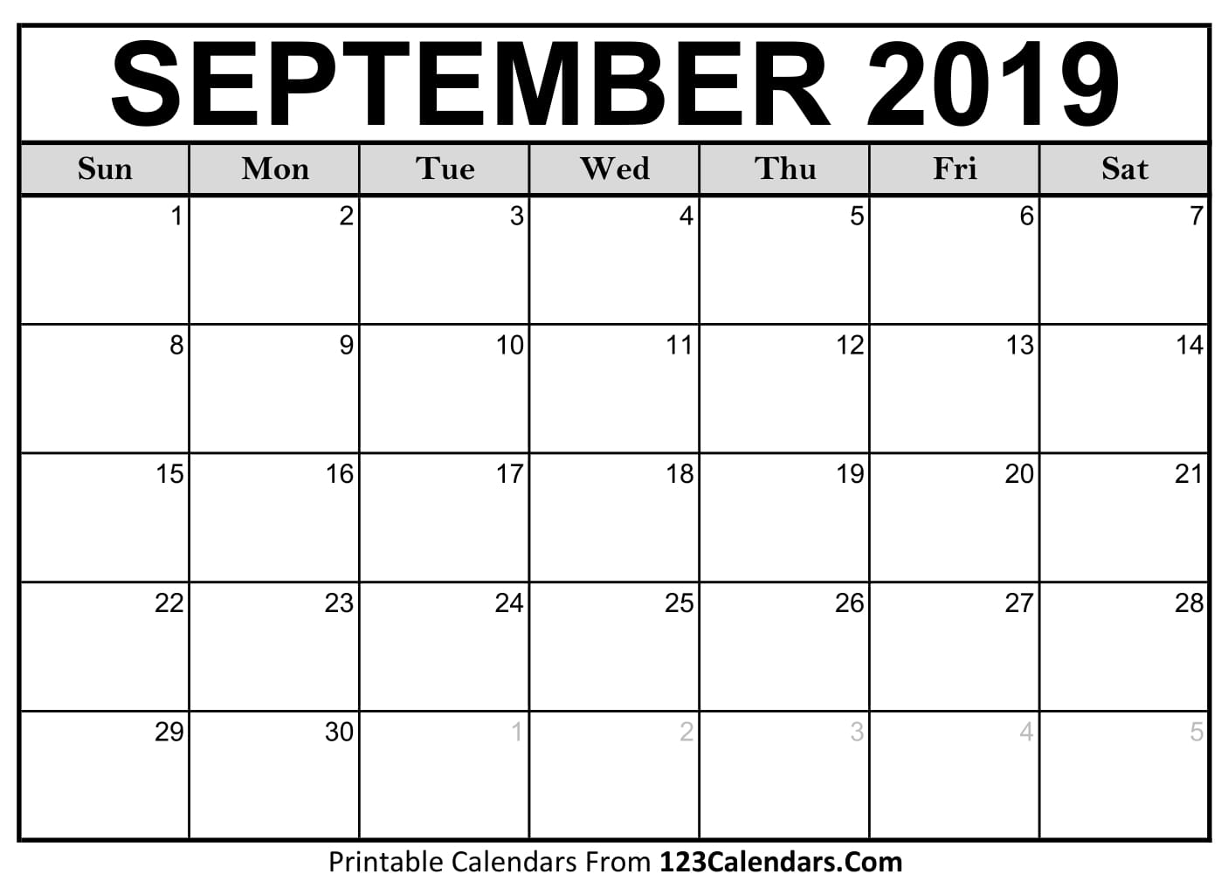

**District Quarterfinals**

**4:00pm**

**JV Districts at Allen HS**

**8:00am**

**Community Pep Rally**

**More details to come**

**JV Practice**

8:30 am

**Varsity Field Trip to UNT 2:30pm**

**Varsity- Rucker Elementary**

**JV Practice**

7:50 am

**Varsity Practice** until 4:30 pm

**\*September 9th: ETF Meeting 6 pm in the MPF classroom**

**\*September 30th: ETF Meeting 6 pm in the MPF classroom**

**JV Practice** 7:50am

**JV Match vs. Allen @ Allen 4:00 pm**

**JV Practice** 7:50am

**JV Match vs. Plano West @ PHS 4:30 pm**

**JV Practice** 7:50am

**JV Match vs. McKinney Boyd @ Boyd 4:30 pm**

**JV Practice** 7:50am

**JV Match vs. Plano East @ PLE 4:30 pm**

**JV Practice**

8:30 am

**JV/Varsity Boys Match vs. Jesuit @ Jesuit**

**4:30 pm**

**JV Practice**

8:30 am

**Varsity Match vs. Plano High @ Prosper 4 pm**

**JV Practice**

8:30 am

**Varsity Practice** until 4:30 pm

**JV Practice** 7:50am

**Varsity Practice** until 4:30 pm

**ETF Meeting 6 pm**

**JV Practice** 7:50am

**Varsity Practice** until 4:30 pm

**JV Practice** 7:50am

**Varsity Practice** until 4:30 pm

**JV Practice** 7:50am

**Varsity Practice** until 4:30 pm

**ETF Meeting 6 pm**

**JV Practice** 7:50am

**Varsity Practice** until 4:30 pm

**JV Practice** 7:50am

**Varsity Practice** until 4:30 pm

**JV Practice** 7:50am

**Varsity Practice** until 4:30 pm

**JV Practice** 7:50am

**Varsity Match vs. Allen @ PHS 4 pm**

**JV Practice** 7:50am

**Varsity Match vs. Plano West @ PLW 4:45 pm**

**JV Practice** 7:50am

**Varsity Match vs. McKinney Boyd @ PHS**

**4 pm**

**JV Practice** 7:50am

**Varsity Match vs. Plano East @ PHS 4 pm**

**NO SCHOOL!**

**Labor Day!**